Game Design Document

Fill up the following document

1. Write the title of your project.

Magical Book

1. What is the goal of the game?

The main goal is that the magical book should get past all the obstacles which are the monsters and get to the “imaginary typewriter” which is magical. It is the main goal because the book is trying to end the story which can only be done by the magical typewriter and after it ends all the monsters will go inside the book and “The end”.

1. Write a brief story of your game.

The story is based on a book called “Goosebumps”, So in the story there is a writer and he writes horror stories which come to life if they open the books, so for this reason he keeps all of his books locked, he writes them with a magical typewirter, so one day one of the the book gets opened. Then all the monsters come out of the book and haunt everyone, so If this has to stop then the monsters should go back in the book and for this we need and alternate ending for the book and then the magical book goes in search for the enchanted typewirter and the monsters become the obstacles and comes between its path .

Which are the playing characters of this game?

* Playing characters are the ones who respond to the user based on the input from the user.
* Cars, monkeys, dinos, wizards, etc., are the playing characters in the game.

|  |  |  |
| --- | --- | --- |
| Number | Character Name | What can this character do? |
| 1 | The magical book | Move with the arrow keys, controlled  by the user |
| 2 |  |  |
| 3 |  |  |
| 4 |  |  |
| 5 |  |  |
| 6 |  |  |
| 7 |  |  |
| 8 |  |  |

1. Which are the Non-Playing Characters of this game?

* Non-Playing characters are the ones that don't have an action or behavior when the user interacts with the game.
* Hurdles, stones, bananas, coins, etc., are non-playing characters in the game.

|  |  |  |
| --- | --- | --- |
| Number | Character Name | What can this character do? |
| 1 | Slappy – the dummy | obstacle |
| 2 | Polar Monkey | obstacle |
| 3 | Warewolf | obstacle |
| 4 | Dwarfs | obstacle |
| 5 |  |  |
| 6 |  |  |
| 7 |  |  |
| 8 |  |  |

Draw your imagination of this game. What does this game look like?

* Draw the game either on your computer or on paper.
* Add images of the game scenes to show each of the playing and non-playing characters at least once.

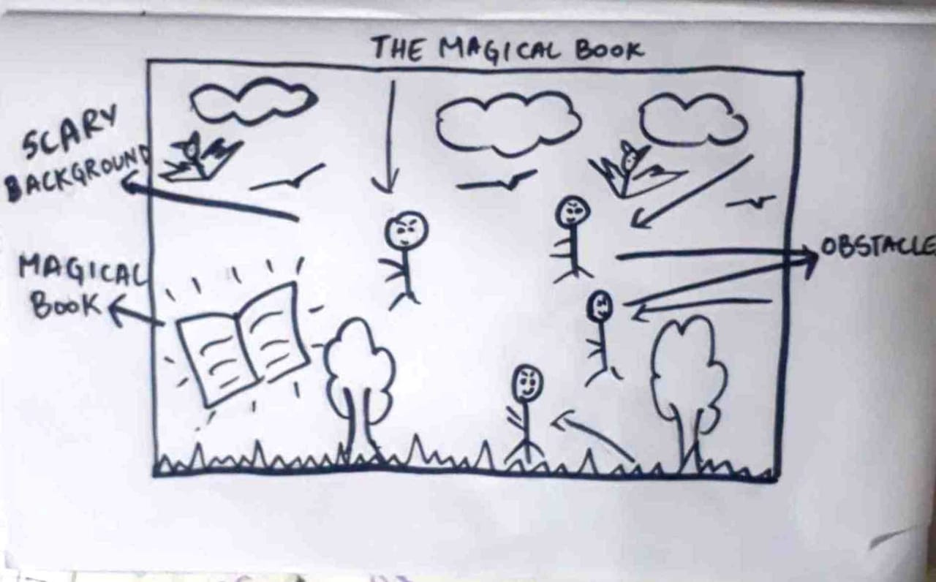

How do you plan to make your game engaging?

In my game, like the obstacles keep on coming and they very attractive and colourful so people will be engaged in it, also the score keeps increasing with checkpoints or levels.